8. Effectively Adapting and Utilizing MRL Criteria

8.1 Introduction
The development of MRLs has been a joint industry and government activity for over a decade. The participants have been experts in both manufacturing and acquisition from numerous DoD OEMs/suppliers, academia, and government. The assessments of manufacturing readiness utilizing MRL criteria have been used on numerous programs with excellent results in identifying and managing manufacturing risk.
In reviewing the successful programs, there are some basic attributes that stand out. First and foremost is having trained Subject Matter Experts (SME) involved in the assessment of manufacturing readiness based on the MRL criteria. Their expertise is essential in not only assessing readiness, but also in adapting the MRL criteria to the given situation. Assessments using the basic MRL criteria will support most applications with only minor adaptions. Terms such as “production relevant”, “production representative”, “pilot line”, and “rate tooling” may have different meanings for S&T, ship, or a space program as opposed to programs for ground vehicles, aircraft, or electronics; therefore notional definitions have been defined within this document in order to clarify the intent of specific terminology.
This chapter provides the user with insight in adapting the MRL criteria to specific situations. Some MRL threads or sub-threads have multiple criteria to address; and while not all criterion may be applicable, the thread or sub-thread should not be ignored. Instead, the thread or sub-thread should be consider only those applicable criterion. While adaptations for assessment can be made for a specific technology or application, traceability to MRL criteria must be maintained to provide a sound foundation for risk management.

8.2 MRL Criteria in the S&T Environment

8.3 MRL Criteria for Sustainment/Maintenance, Repair & Overhaul (MRO) and Depot Activities

8.3.1 Using MRL Criteria to Enhance Product Support Management
The DoD Product Support Manager (PSM) Guidebook, a Best Practice, stresses proper early planning for Life Cycle Logistics (LCL) which corresponds to early planning for manufacturing activities. The relationship of assessments of manufacturing readiness using MRL criteria to Product Support Decision Points or activities begins in the Pre-Material Solution Analysis phase. The DoD PSM Guidebook stresses the use of Sustainment Maturity Levels (SMLs) to identify decisions/activities for Product Support. SMLs have a direct correlation to MRL criteria as depicted in figure 8.1.
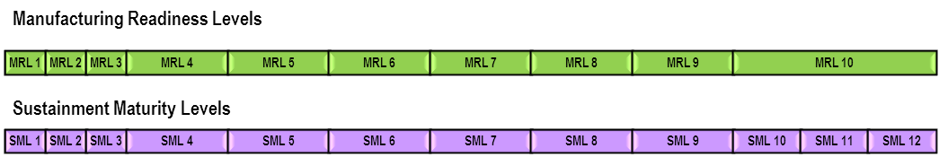
Figure 8.1 – Relationship of MRLs to SMLs
Assessments of manufacturing readiness using the MRL criteria can support the SML activities in the progression of a program where sustainment is properly addressed as a normal day-to-day activity. Existing depot-proven manufacturing procedures and processes should be utilized as much as possible, and equipment utilized must meet process capability requirements.

8.3.2 Using MRL Criteria to Enhance Logistics Assessments
The DoD Logistics Assessment Guidebook states that a thorough Logistics Assessments will assist leaders in making informed decisions at milestones and/or at key program decision points. Many of the criteria in the Guidebook are directly supported by the MRL criteria. Assessing manufacturing using the MRL criteria provides better understanding of the manufacturing capability of suppliers, allowing decisions based on objective data. Minor adaptations to the language for the assessment process using MRL criteria may be required.

8.3.3 Using MRL Criteria to Enhance Depot Activities
Assessing depot manufacturing capability using the MRL criteria provides better understanding of the organic depot and depot supplier capabilities. Often, depot support decisions have to be adjusted based on “fact of life” changes. For example, support of a product was originally contracted to a business; but due to unforeseen circumstances that business is no longer available. The support activities would likely be absorbed by a military depot. If this product requires processes, capabilities, or components that are not within the current depot capability, then these need to be “matured.” Assessments of manufacturing (using MRL criteria) need to be performed to identify and “mature” the necessary manufacturing activities to support the product.
Figure 8.2 depicts a situation where the depot was directed to stand-up (unplanned) a capability for a product (which is Post-MS C/IOC). If no engineering technical data is available, the assessment of manufacturing readiness could have a target of MRL 5 (which does not support an SML 8). If limited data is available, the assessment of manufacturing readiness could have a target of MRL 6 (not supporting an SML 8). If a majority of data is available, the assessment of manufacturing readiness could have a target of MRL 7. Unless all data and processes are in place to support a product, it will take time, funding, and resources to achieve MRL 8 and support an SML 8.
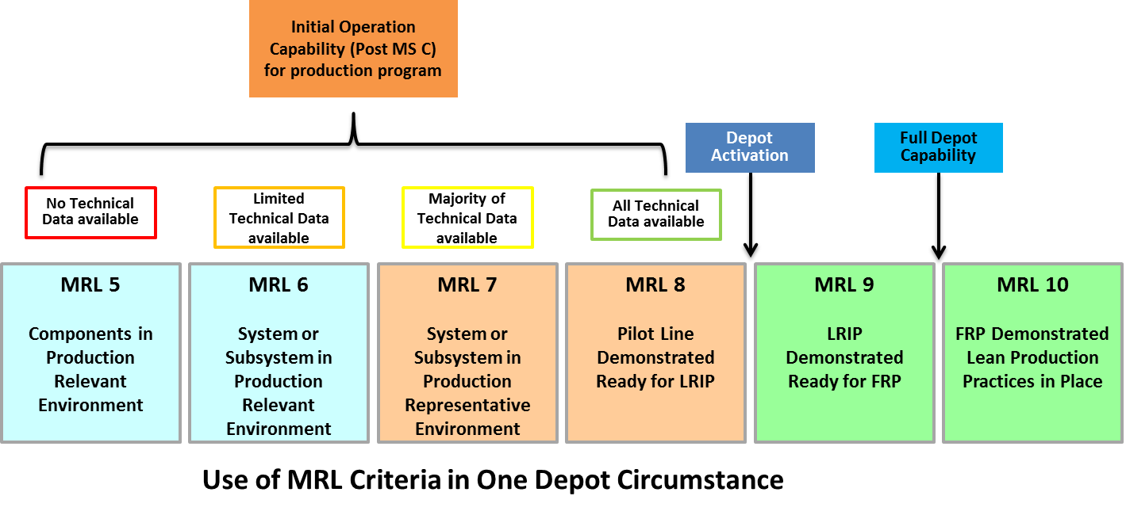
Figure 8.2 – One Depot Circumstance

8.3.4 Summary
In summary, assessments of manufacturing readiness using MRL criteria can support sustainment, MRO, and depot activities. A SME trained in assessment of manufacturing readiness and logistics planning is essential for product support management, logistics assessments, and depot activities. It is critical that the stakeholders work together to understand what is needed to meet the MRL criteria in their application. MRL criteria must be linked to program or depot objectives to identify the risks that need to be managed. Assessments of manufacturing are essential for cost effective and reduced cycle times for sustainment and depot activities.

8.4 MRLs for Single or Limited System Acquisition

8.5 MRL Criteria for Industry

8.6 Summary
Assessments utilizing MRL criteria can be performed wherever there is manufacturing activity. Furthermore, one of the key attributes to effectively and efficiently conducting assessments using MRL criteria is to have trained manufacturing SMEs performing the assessments. Trained expertise is needed in adapting the MRL criteria to each specific situation. Terms such as “production relevant”, “production representative”, “pilot line”, and “rate tooling” may have different meanings for S&T, ship, or a space program as opposed to programs for ground vehicles, aircraft, or electronics. The goal is to determine what these terms mean in each situation and adapt the criteria appropriately.
Whether conducting S&T programs, building one unit or thousands, or providing sustainment, determining the manufacturing maturity is essential. Manufacturing assessments using the MRL criteria are a very effective method to determine the maturity and understand the manufacturing risk at all key program decision points, whether within a company or within the government.

